**Café Execution Tools**

1. **Introduction**

Selecting and executing café scripts can be accomplished in several different ways. First way is the use the convention method of right clicking and selction the Run This Feature from the pull down menu. Each script is ran individually by using the values in the settings.yml file. For single script, this method is effective but when more than one URL is needed, or when several scripts needs to be executed, this method is very inefficient. Two steps needs to be accomplished to make multi script multi ulr execution efficient. First step is selecting what script, and second step is selection the urls.

1. **Selecting scripts to be executed**

A tag is used to identify a group of scripts for execution. Giving one script a tag is not effective because a single script can be run individually, without the use of a tag. A tag is placed on the first line of the script and starts with the @ sign, contains no spacing, and is case sensitive. Usually tags are named according to purpose such as @smoketest,@ regression, etc, but tag of @wip is a used to tell café to completely skip this script.

The process of tagging scripts, remembering that scripts are tagged and with what tag sometimes can be difficult when there are many scripts, and many folders of script involved. The ruby script called **Findtags.rb** will transverse all the folders under the \features\specifications of the project, will locate, display and produce a report of all tagged scripts.

To run Findtags.rb script:

1. Verify that the Findtags.rb script is located in the root folder for the project.
2. Open up command prompt and type ruby Findtags.rb
3. The script will display all the scripts and tags. In order to save space, the console will not display the scripts that contain the @wip tag.

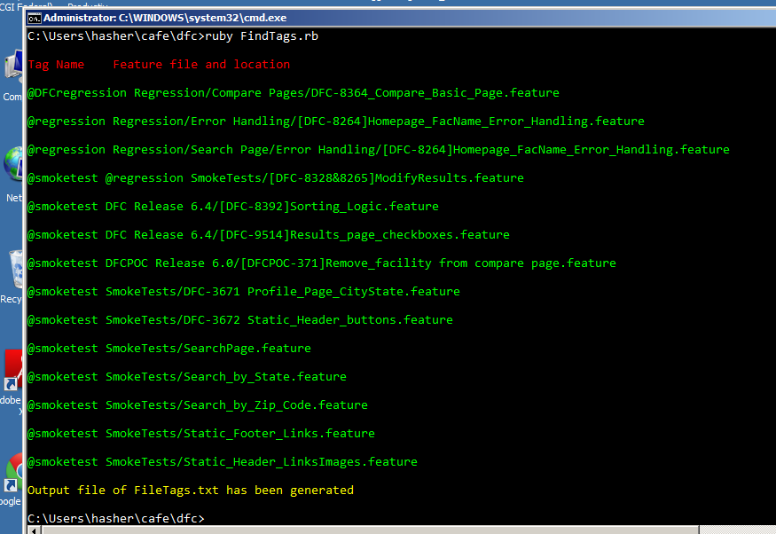

Figure1 Screen display

1. Along with the screen output the Findtags.rb script will also generate an output file called FileTags.txt. The screen output contains all tags including the @wip tags.

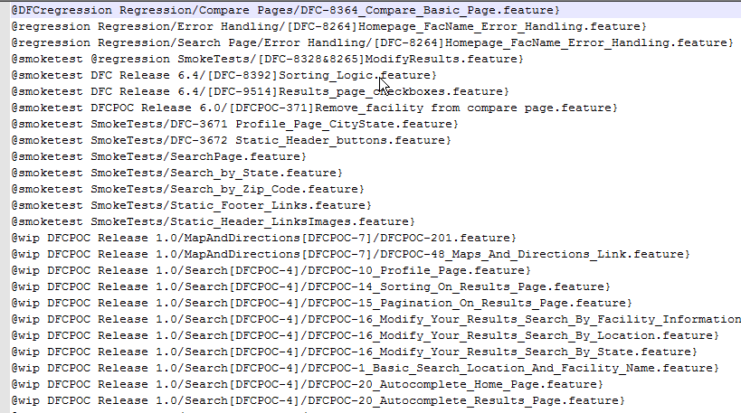

Figure 2 Sample Output file Findtabs.txt

1. **Executing Multi script in Multi environments**

The **EnvironmentTesting.rb** script will run the selected scripts on a single environment, or on multi environments. The menu for this script is fed off the environment.yml file located in the config folder for the café project. This script reads the environment.yml file for both cms and medicare projects. Here is a screen shot generated from the EnivornmentTesting scriptand the environment.yml file for the acronym project, (cms) project. Any comments are ignored by the EnvironmentTesting script

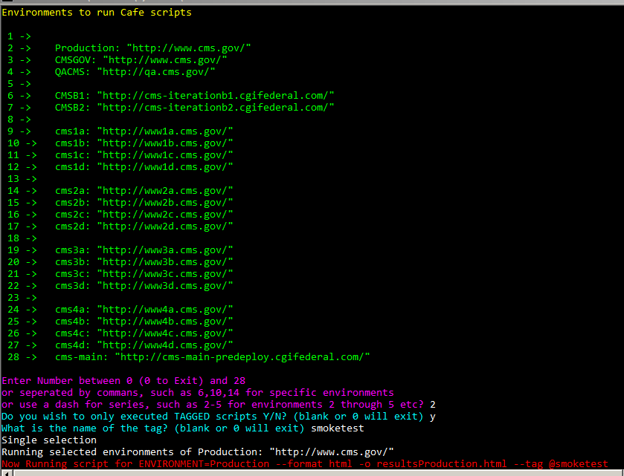

Figure Menu generated by the EnivornmentTesting script for the acronym project

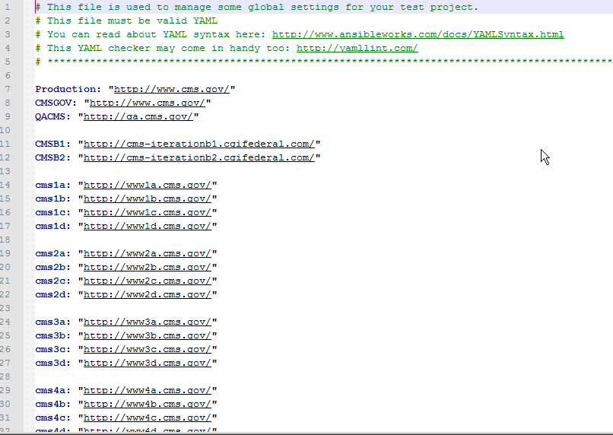

Figure Envoronment.yml from acronym project

Environments can be selected by three different ways, a single environment, a series separated by commas, or by a range by using a dash. After an envirornment has been selected either by a single number such as 12, or a series of 3,5,8 or a range 3-5. The script will as if any tags will be use, this is a Y/N question, if Y then the next prompt will then name of the tags. When using tags do not provide the @, the script will provide that symbol to the café command.

To run the **EnvironmentTesting.rb** script

1. Verify that the **EnvironmentTesting.rb** script is located in the root folder for the project.
2. Open up command prompt and type ruby EnvironmentTesting.rb
3. Select the environment, single, series or range values
4. Answer whether tags are used, and if so provide tag names without the @ sign

The EnvironmentTesting script will not checks if information is incorrect or invalid. It will not prompt if a blank selection is name (such as in selecting 8 in figure 3), misspelled or missing tags, etc. The script will however display the current café command, along with tag and environment settings. In the following example, there was a smoketag used, on the Production environment (Figure 5), and a blank environment selected (figure 6). The café command will be highlighted in red.

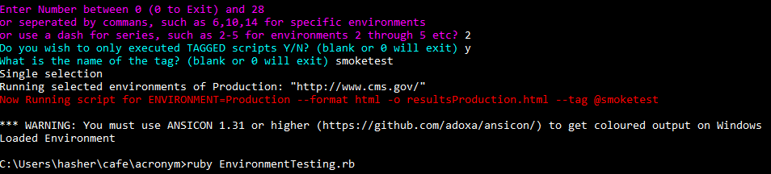

Figure Script Indicators

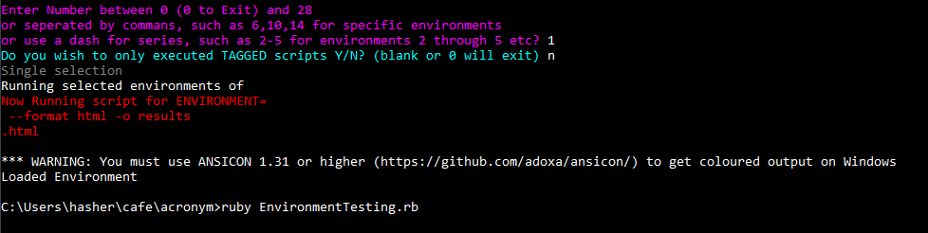

Figure Blank environment selected